HANDOVER DOCUMENT
AI-Assisted Traffic Control Plan Drafting
Solution plan, architecture diagram and decision records, based on the BRD and discussion notes
Prepared by: Sahil
Date: 29 September 2026
Status: Draft for internal team review
Source: Traffic Control Plans - Business Requirements Document & Discussion Notes (notes dated 8/17/26; questions opened 08/27/2026). Requirement IDs (BR-, IS-, OOS-, A-, C-, D-, R-) refer to that document.
Note: this replaces the earlier handover. That version assumed an external client, 700-800 plans a week and system-fetched imagery. The BRD shows an internal Telecom team, 80-100 plans a week and user-supplied imagery, so the plan has been rewritten.

1. One-page summary
Story in one line: the user submits location, work details and imagery; the system reads the road, a rules engine decides what goes where, code draws the plan as a labeled draft, and a Traffic Control SME reviews it, gives feedback and approves it before it goes on to AutoCAD.
Principle: AI interprets, rules decide, code draws, the SME approves.
Item | Summary
Problem | Experienced staff draft each simple plan by hand in AutoCAD, 2-3 hours per plan, with demand up to 80-100 plans a week (about 160-300 drafting hours a week).
Why earlier AI attempts failed | Copilot and ChatGPT produced inaccurate work-zone, cone and sign placement on aerial imagery, needed extensive prompting, and returned text or images that could not be copied into CAD. ChatGPT is also not allowed in the office.
Proposed solution | A governed drafting assistant: intake and eligibility gate, site understanding, deterministic rules engine, code-drawn output, SME review loop, versioning and audit.
MVP scope | Low-complexity work (for example roadside pole setups), one jurisdiction, draft output only, deployed inside Telecom.
Out of scope | Complex scenarios, unattended approval, enterprise rollout, and (per the BRD) automated AutoCAD package generation. ADR-010 asks whether a DXF geometry export fits.
Biggest gating items | Security, legal and architecture review; the SME sample plans and rule approval; the decision on DXF output; simple-versus-complex criteria.
Timeline (estimate) | About 5-6 months to a production-ready pilot, to be confirmed after Discovery (section 12).

2. Background and business case

2.1 Current state
- Traffic control plans are created manually in AutoCAD with work zones, MUTCD signs and cone layouts.
- Simple plans take 2-3 hours of drafting each; weekly demand can reach 80-100 plans.
- Plans must meet the MUTCD baseline and varying state and local requirements.
- Experiments with consumer AI tools have not consistently met visual, roadway placement or quality standards.

2.2 Desired future state
The business submits location, project, imagery and jurisdiction information and receives a compliant draft plan for eligible low-complexity work. An engineer reviews and corrects the draft before CAD finalization or work preparation. Repetitive effort falls while human judgment, safety, traceability and approval are kept.

2.3 Objectives and measures (from the BRD)
ID | Objective | Measure | Owner
OBJ-1 | Reduce drafting effort for eligible simple plans | Average drafting time per eligible plan; baseline now, set target during pilot | TBD
OBJ-2 | Increase throughput without matching headcount growth | Eligible plans completed per week; target after baseline | TBD
OBJ-3 | Maintain plan quality and compliance | First-pass SME acceptance, permit revision and rejection rates; targets TBD | TBD
OBJ-4 | A safe and governed AI-assisted process | 100% of outputs labeled draft and routed through human approval | TBD
Action: every measurement owner is TBD and every target is open. Name owners and capture the current drafting-time baseline in Phase 0.

3. Scope and eligibility

3.1 In scope (BRD 6.1)
ID | Capability | Description
IS-001 | Plan intake | Aerial imagery, screenshots, KML/KMZ, coordinates, project metadata, scope, jurisdiction
IS-002 | Roadway and work-location interpretation | Roadway geometry, lanes, shoulders, sidewalks, pole or manhole position relative to traffic
IS-003 | Draft recommendation | Work zone, cone, taper, sign, lane-control, vehicle and worker-protection placement
IS-004 | Regulatory context | MUTCD baseline plus an approved initial state or local source set
IS-005 | Human review and approval | Draft label and SME review before downstream use
IS-006 | Revision and versioning | Reviewer or permitting feedback, versions, change identification

3.2 Out of scope (BRD 6.2)
- OOS-001 Fully automated package generation; OOS-002 automated AutoCAD file creation (later phase, see ADR-010).
- OOS-003 Complex scenarios: roundabouts, ramps, multi-lane closures, center-lane work, high-volume intersections, unusual cases.
- OOS-004 Unattended approval or release; OOS-005 enterprise rollout.

3.3 Draft eligibility gate (for SME approval, answers Q2)
A job is automated only if all of these hold; otherwise it goes to manual drafting and the reason is shown. Criteria are a starting proposal from the notes and BRD, and Steve Oliveira must confirm them.
- Jurisdiction is one of the supported rule packs (MVP: one).
- Work type is a supported pattern (for example roadside pole work).
- Work is at a single site or a simple corridor made of repeated segments.
- No ramp, roundabout, lane merge, high-volume intersection or manhole-in-lane work is present or nearby.
- No multi-lane closure and no center-lane work.
- Location, scale and jurisdiction inputs are present and pass validation.
- Site model confidence is above the agreed threshold, or the user has confirmed low-confidence items.

4. Solution overview
Layer | Technique | Why
Understand inputs and instructions | LLM (in-tenant) producing validated JSON | Human language is messy
Read the road | GIS data plus segmentation and detection models, fused with confidence scores | Imagery is messy; GIS gives a reliable base
Decide layout and distances | Deterministic rules engine with versioned rule packs | Exact, repeatable, defensible
Draw | Python drawing code from one plan model (PDF, DXF) | Exact scale and standard symbols
Approve | Traffic Control SME | Safety and liability
Why not let an AI or image generator produce the plan directly: the SME saw inaccurate placement and non-CAD output, image models cannot guarantee scale, symbols or text, and a plan cannot be audited if it changes on every run. See ADR-002 and ADR-003.

5. End-to-end flow (11 steps; diagram on the next pages)
- Input: the user submits location (KML/KMZ or coordinates), jurisdiction, work type and scope, duration, day or night, and imagery.
- Clean-up: the LLM turns free-text notes into a strict schema and flags missing items.
- Scale: the system georeferences the imagery or applies a two-point scale calibration.
- Eligibility: the gate decides whether the job is automated or routed to manual drafting.
- Understand the road: GIS data and vision models produce a fused site model with confidence scores.
- Confirm: low-confidence items are shown to the user to confirm or correct on the map.
- Choose the layout: the rules engine selects the jurisdiction pack and standard pattern.
- Calculate and place: sign sequence, taper, buffer and cone spacing are calculated, and each device is placed with an ID; approved patterns are repeated across poles or segments.
- Validate: every rule is checked and issues are listed with rule citations.
- Draw and export: the plan is rendered with symbols, IDs, dimensions, legend, title block and north arrow, stamped as a draft, and exported as PDF (and DXF if ADR-010 is approved).
- Review: the SME reviews, gives feedback, approves; every version, instruction and approval is logged.

Diagram, part 1: inputs, intake and eligibility
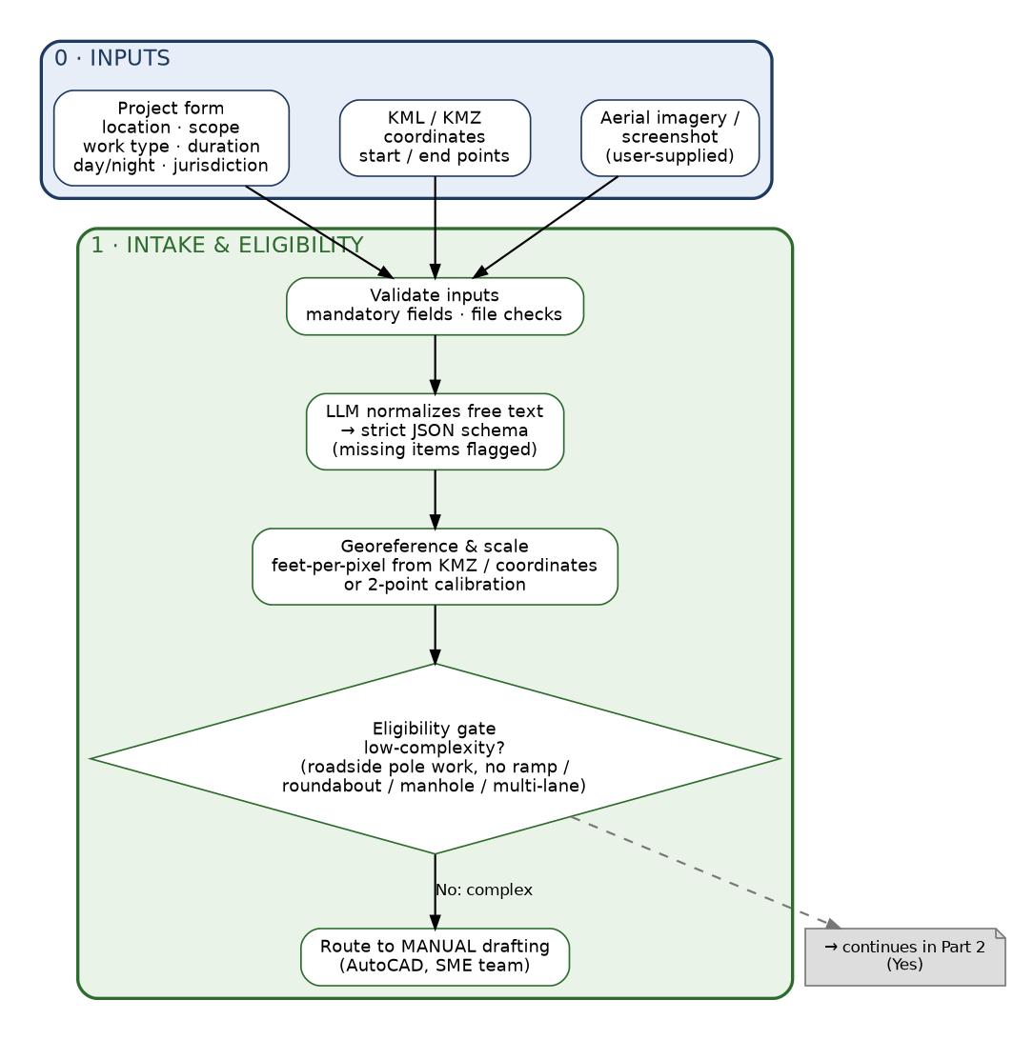

Diagram, part 2: site understanding
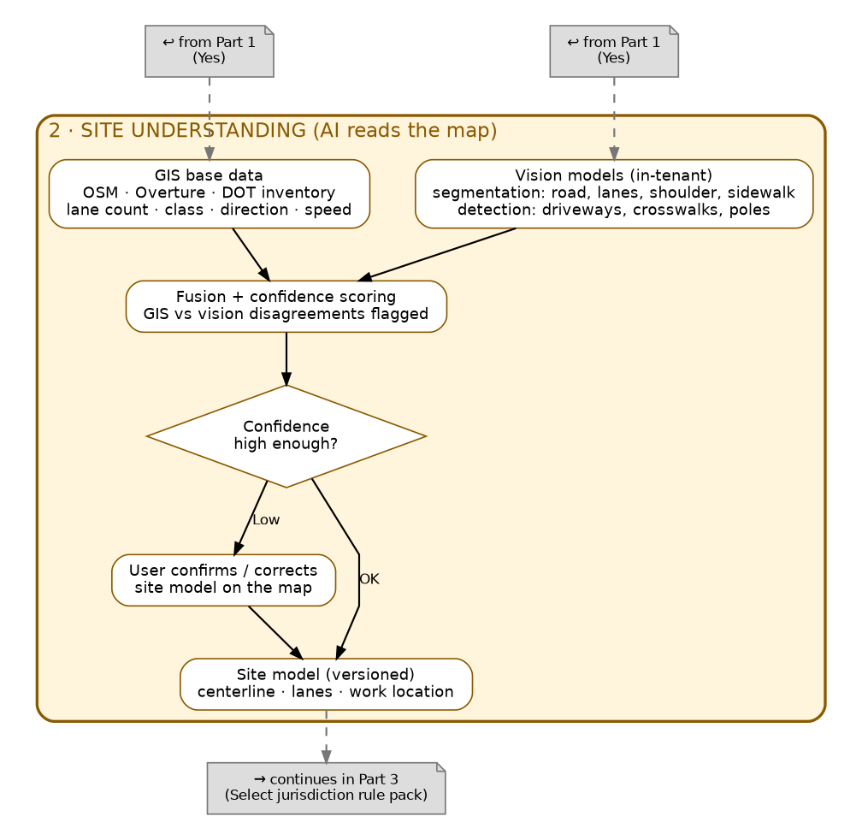

Diagram, part 3: rules, layout and drawing
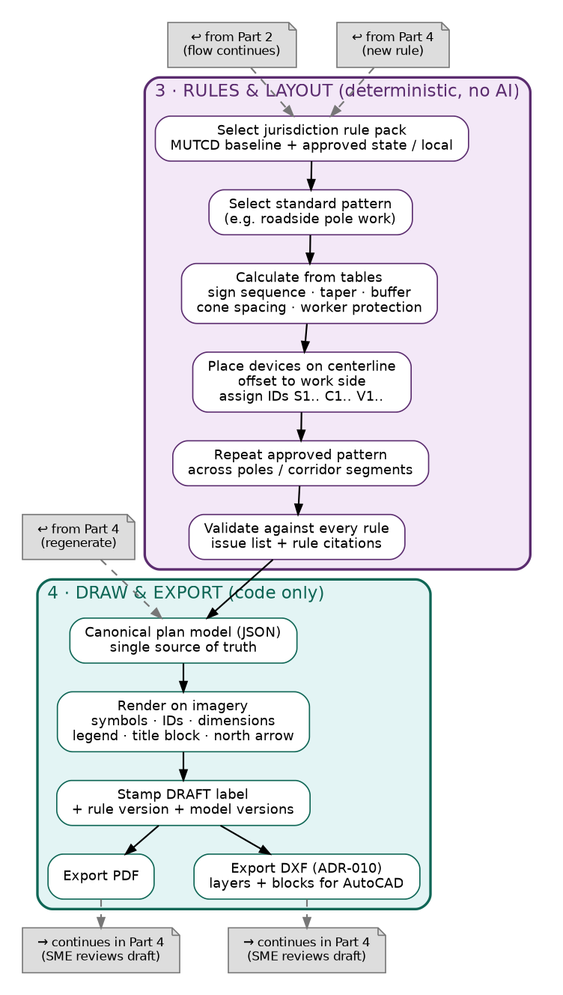

Diagram, part 4: review loop, approval and learning
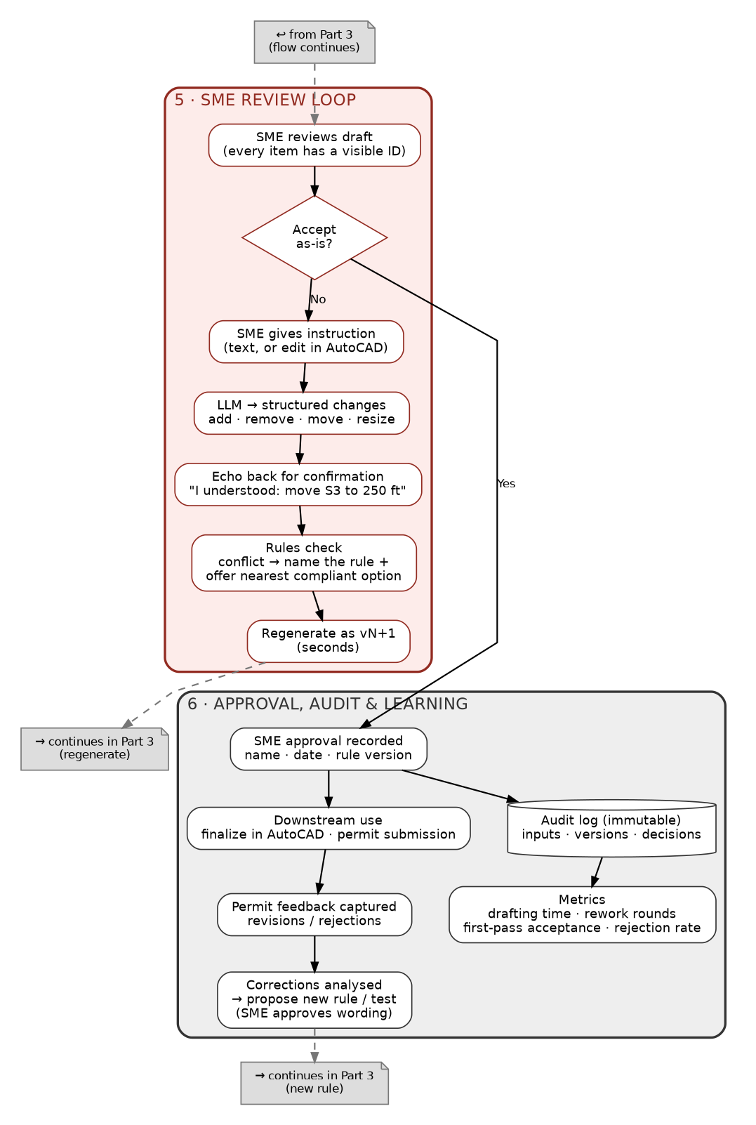

6. Requirements traceability
BR | Requirement (short) | Design element | ADR
BR-001 | Submit location, scope, imagery, mapping, jurisdiction | Intake form, KMZ/coordinate parser, scale calibration | 006
BR-002 | Separate eligible simple work from complex work | Eligibility gate with manual routing | 005
BR-003 | Receive a draft plan concept | Rules + layout + drawing pipeline | 002, 003
BR-004 | Account for geometry, work location, cones, signs, tapers, lane controls, vehicles, worker zones | Site model, rules engine, device placement | 007, 004
BR-005 | Reference MUTCD and jurisdiction requirements | Versioned jurisdiction rule packs with clause links | 004
BR-006 | Label all output as draft; SME approval | Draft stamp, approval gate | 001, 014
BR-007 | Capture feedback and create revised versions | Review loop, structured instructions, versions | 012, 013
BR-008 | Traceability of inputs, references, versions, decisions | Immutable audit trail | 013
BR-009 | Repeat an approved pattern across poles or segments | Pattern templates and linked instances | 015
BR-010 | Pilot quality and performance measures vs manual | Golden set, shadow pilot, metrics | 017

7. Architecture

7.1 Components
Component | Responsibility
Web UI | Intake form, map confirmation and scale calibration, plan preview, item IDs, feedback box, version history, approval
Input service | Validation; LLM normalization into the job schema; KML/KMZ parsing; eligibility gate
Map/geo service | Imagery handling, georeferencing, GIS data retrieval and caching
Vision service | Segmentation and detection inference, confidence scoring, fusion with GIS data (in-tenant GPU)
Rules engine | Versioned jurisdiction packs, pattern selection, calculations, placement constraints, validation, conflict explanations
Layout and pattern service | Places devices along the centerline, applies repeated patterns
Renderer | Reads the plan model and writes PDF and DXF with draft labels
Feedback interpreter | LLM converts instructions to structured operations; echo-back; hands changes to the rules engine
LLM gateway | Single controlled path to approved models; schema validation; prompt and model version logging
Audit and storage | Immutable versions, inputs, approvals, events; retention rules
Queue and workers | Batch handling for peak weeks (80-100 plans)

7.2 Core data model
Entity | Key fields
Job | ID, requester, jurisdiction, work type, scope, duration, day/night, status, eligibility result and reasons
Input | File or text, hash, type (KMZ, coordinates, image, note), scale info, validation result
SiteModel | Version, centerline, lanes, shoulders, sidewalks, work location, per-item confidence, user corrections
RulePack | Jurisdiction, version, effective date, approver; Rule: ID, source clause, applies-when, table or formula, tests
Plan and PlanVersion | Version number, parent, input hash, rule pack version, model versions, status (draft, in review, approved)
Device | ID (S1, C5), type, symbol reference, station and offset along the centerline, rule that required it
Instruction and Change | Reviewer text, parsed operations, confirmation, diff, resulting version
Approval | Approver, date, plan version, rule pack version, comments
AuditEvent | Actor, time, action, object, before and after

7.3 Rule record (illustrative shape only)
Field | Example (placeholder values, not real requirements)
rule_id | RULE-EX-001
source | Document name, edition, clause number
applies_when | work_type = roadside pole; posted speed within a given band; road class = given class
calculation | Lookup in the table taken from the source clause; result in feet
produces | Advance warning signs with spacing and sign codes; taper length; cone spacing
tests | Expected outputs taken from SME-approved past plans
approved_by / date | SME name and date (plain-English wording approved)
All real distances and sign codes come from the approved standards and the SME rule catalog built in Phase 0. This document does not contain them.

8. Inputs and outputs

8.1 Proposed mandatory inputs (answers Q3 for discussion)
- Location: KML/KMZ or coordinates (start and end points for corridors).
- Jurisdiction (must match a supported rule pack).
- Work type and which side of the road, or the pole position relative to traffic.
- Work scope, duration, day or night.
- Imagery with georeference or a two-point scale calibration; minimum resolution and freshness to be agreed.
- Speed limit if it cannot be read from map data.

8.2 Outputs
- On-screen preview with clickable item IDs and rule citations.
- PDF plan labeled as an AI-generated draft.
- DXF geometry with layers and blocks matching company standards (pending ADR-010).
- Validation report: rules checked, issues, overrides, confidence flags.
- Version history and audit record.

9. Review loop
- The SME opens the draft; every device has a visible ID.
- The SME types an instruction, for example "Move S3 200 ft earlier and add a sign before the taper", or edits the DXF in AutoCAD.
- The LLM converts the text to structured operations (add, remove, move, resize).
- The system echoes "I understood: ..." and the SME confirms.
- The rules engine checks the change; a conflict names the rule and offers the nearest compliant option.
- The plan regenerates in seconds as the next version.
- The SME approves; name, date, rule pack version and full version history are logged.
Ambiguous instructions such as "make it safer" trigger one clarifying question. Repeated corrections are reviewed regularly and can become new rules, with the SME approving the wording. Permitting-office feedback is captured against the version it applies to.

10. Security and governance
- Data classification for location, customer and infrastructure data, agreed with Security before any real data is used.
- Everything, including models, runs in the approved Azure tenant with private networking, encryption and least-privilege roles.
- Confirm that no model provider retains or trains on the data.
- Uploaded KMZ and free text are untrusted: schema validation, no instructions followed from inside files.
- Retention and deletion rules for inputs, imagery and plan versions.
- Reviews required by the BRD: security, legal, architecture, data governance (D-002).

11. Evaluation and pilot
Stage | What is measured
Offline (golden set) | Lane and road detection accuracy; work-location placement error; rule unit tests; device type and position match against SME plans; zero rule-violation regressions between releases
Shadow pilot | Same real jobs drafted manually and by the system; drafting-to-approved time; rework rounds per plan; first-pass SME acceptance
Downstream | Permit revision and rejection rates versus the manual baseline
Adoption | SME effort per review, share of jobs routed to manual, and share of small tweaks (decides ADR-020)
Targets are set after the baseline is measured, as the BRD requires. The Phase 0 vision benchmark also produces the accuracy figure used to promise results.

12. Delivery plan
Phase | Estimate | Deliverables | Gate
0. Discovery and governance | 3-4 weeks | Jurisdiction and scenarios chosen; sample plans and inputs collected; symbol library and AutoCAD standards; rule catalog drafted and approved; eligibility criteria; data classification; hosting and model approvals started; golden set; vision benchmark; decisions on ADR-010 and ADR-021; metric owners and baseline | SME approves rules; Security agrees hosting
1. MVP build | 8-10 weeks | Full flow for one pattern in one jurisdiction; UI; PDF (and DXF); text review loop with IDs; versioning; audit log; draft labels | Architecture review; golden tests pass
2. Pilot and hardening | 6-8 weeks | Shadow pilot on live jobs; pattern repetition across poles and corridors; accuracy tuning; more patterns; measure against baseline; decide on drag-and-move | Sponsor reviews pilot results
3. Production readiness | 3-4 weeks | Security and legal sign-off; managed hosting, monitoring, backup; training and help docs; support ownership | Release approval
Later | n/a | Additional jurisdictions, drag-and-move editor, complex scenarios, DWG output | Business case
Estimates are planning figures and should be confirmed after Discovery. Approvals (security, legal, architecture) are the most likely cause of delay and should start on day one.

Roles and owners
Role | Person named in the BRD | Responsibility in this plan
Business Sponsor | Rick Coburn | Scope, priorities, release approval, decisions on ADR-010 and ADR-021
Traffic Control SME | Steve Oliveira | Sample plans, rule wording approval, eligibility criteria, draft review and approval
IT / Architecture | Kiran | Architecture and hosting decisions (ADR-018)
Security | James Gregorio | Data classification, hosting and access approval (ADR-016)
Discussion attendees | Rachel MacDonald, Nathan Cannon, Cynthia Marrero (and Jake mentioned) | Backlog evaluation, Azure AI Foundry access, next steps; roles to be confirmed
Delivery team (to staff) | TBD | Backend and rules, GIS and vision, rendering, frontend, and one domain expert working with the SME

13. Risks
ID | Risk | Mitigation | Owner
R-001 | Devices or zones placed incorrectly | Rules engine, validation, eligibility gate, SME review, golden tests | TBD
R-002 | Local rules differ from federal baseline | Curated jurisdiction pack, source ownership, local checks | TBD
R-003 | AI draft treated as final | Permanent draft label, approval gates, training | TBD
R-004 | Permitting offices reject or revise plans | Version and feedback capture, measured rejection rates | TBD
R-005 | Sensitive data handled through AI | Approved hosting, access control, retention, security review | IT / Security
New 1 | Wrong or missing image scale gives wrong distances | Scale check at intake; reject unscaled images; show scale on output | TBD
New 2 | Vision accuracy too low on real imagery | GIS first; confidence gating; user confirmation; benchmark in Discovery | TBD
New 3 | Output format decision (DXF) is delayed or rejected | Decide in Phase 0; if PDF only, expect a smaller time saving | Sponsor / SME
New 4 | SME availability limits throughput (A-003) | Plan review time; track review effort; reduce rework via IDs | TBD
New 5 | Approvals delay hosting and model access | Start reviews in Phase 0 | IT / Security
New 6 | Rule catalog is incomplete for the chosen jurisdiction | Start with one pattern; rule-gap log from corrections | SME

14. Open questions and decisions
# | Question | Notes | Status
1 | Which jurisdiction and representative simple scenarios for the MVP? | Roadside pole setups are the named example | Open (BRD)
2 | What rules define simple versus complex work and force manual routing? | Draft criteria in section 3.3 | Open (BRD)
3 | Which input fields and quality standards are mandatory? | Proposal in section 8.1 | Open (BRD)
4 | What output format for MVP and for AutoCAD handoff? | ADR-010 recommends PDF plus DXF | Open (BRD)
5 | Which models are approved and available in the Azure tenant? | ADR-009 | New
6 | Which imagery source is approved, and who owns the licensing? | ADR-006 | New
7 | Where do the company symbol library, layers and title block come from? | Needed for DXF and drawing | New
8 | May an SME override a rule, and how is it recorded? | ADR-021 | New
9 | Who owns rule updates when regulations change? | ADR-004 | New
10 | Who are the measurement owners and what is the baseline drafting time? | BRD 5 | New
11 | Deployment and support ownership after go-live | ADR-019 | New

15. Next steps
- Share this document with the team and the named stakeholders for review.
- Ask Steve Oliveira for representative simple plans, source inputs and expected outputs (A-001, D-001), plus the AutoCAD symbol library and layer standards.
- Hold a decision session on ADR-010 (DXF), ADR-021 (overrides) and the eligibility criteria.
- Start the security, legal, architecture and data-governance reviews (D-002).
- Confirm which models are available through Azure AI Foundry.
- Agree the MVP jurisdiction and pattern, then begin Phase 0.

Appendix A: Architecture Decision Records
Status key: Accepted (mandated by BRD) means the BRD already fixes the decision. Proposed means recommended and awaiting approval. Decision needed means a stakeholder choice is required before the design can proceed.
ADR | Title | Status
ADR-001 | Output is an advisory draft, never final; SME approval is mandatory | Accepted (mandated by BRD)
ADR-002 | Hybrid design: AI interprets, rules decide, code draws | Proposed
ADR-003 | No generative image models for plan artwork; plans are drawn as vectors by code | Proposed
ADR-004 | Deterministic rules engine with versioned jurisdiction rule packs | Proposed
ADR-005 | MVP is limited to low-complexity work in one jurisdiction, behind an eligibility gate | Accepted (mandated by BRD)
ADR-006 | Inputs: KML/KMZ and coordinates first; imagery must carry scale | Proposed
ADR-007 | Site understanding is GIS-first, with vision models fused in and confidence-gated | Proposed
ADR-008 | Vision models: open source, run in the company tenant, permissive licenses only | Proposed
ADR-009 | LLM access: in-tenant through Azure AI Foundry, behind a model-agnostic gateway | Proposed
ADR-010 | Output formats: PDF and DXF generated from the same model | Decision needed
ADR-011 | A canonical plan model is the single source of truth | Proposed
ADR-012 | Review loop uses item IDs and structured instructions, confirmed before they are applied | Proposed
ADR-013 | Every plan version is stored immutably with a full audit trail | Proposed
ADR-014 | Permanent AI-draft label and approval gates on every export | Proposed
ADR-015 | Approved patterns can be repeated across poles and corridor segments | Proposed
ADR-016 | Security and data governance come first: approved hosting only, least privilege, untrusted inputs | Proposed
ADR-017 | Evaluate against SME plans, then run a shadow pilot against the manual baseline | Proposed
ADR-018 | Technology stack | Proposed (confirm with IT/Architecture)
ADR-019 | Delivery is phased with human gates; AI-assisted development is allowed under golden-test control | Proposed
ADR-020 | Drag-and-move editor and complex scenarios are deferred | Proposed (deferred)
ADR-021 | Rule conflicts and overrides | Decision needed

ADR-001: Output is an advisory draft, never final; SME approval is mandatory
Status | Accepted (mandated by BRD)
Traces to | BRD C-002, OOS-004, BR-006, OBJ-4, R-003
Context | AI output can carry safety, compliance and liability exposure if used unreviewed. The BRD states AI output is advisory and cannot replace professional judgment.
Decision | Every export is stamped as an AI-generated draft. There is no code path that marks a plan final. An authorized Traffic Control SME must review every draft, and the approval is recorded against a specific plan version. The approved draft goes on to AutoCAD finalization; it is not the final deliverable.
Alternatives considered | Auto-release of high-confidence plans (rejected: liability). Unlabeled outputs (rejected: users may treat a concept as final).
Consequences | SME capacity becomes the throughput limit (A-003). Needs an approval UI, a watermark on all exports and an audit record.

ADR-002: Hybrid design: AI interprets, rules decide, code draws
Status | Proposed
Traces to | BRD 4.2, notes 8/17/26; BR-003, BR-004, BR-005
Context | The SME found Copilot and ChatGPT produced work-zone, cone and sign placements that were inaccurate on aerial imagery and needed heavy back-and-forth prompting. Placement must be exact, repeatable and defensible.
Decision | Split the system into three layers. AI reads the messy parts (imagery, free text, reviewer instructions). A deterministic rules engine decides devices, distances and layout. Drawing code renders the result. The SME approves.
Alternatives considered | End-to-end LLM or multimodal generation of the plan (rejected: inaccurate, different result each run, cannot be audited). Rules only with no AI (rejected: cannot read maps or free text).
Consequences | The rules engine and drawing code are most of the work and most of the value. Results are predictable and auditable. AI failures are contained to input interpretation and are caught by confidence checks and review.

ADR-003: No generative image models for plan artwork; plans are drawn as vectors by code
Status | Proposed
Traces to | Notes: Copilot output was text or non-CAD images; AI-generated aerial images risk permitting revisions; BR-004
Context | Image-generation models paint plausible pictures. They cannot guarantee scale, correct MUTCD symbols, or correct text and numbers, and their output cannot be copied into CAD.
Decision | Plans are produced by drawing code from a structured model. The user imagery is used only as a background layer. Standard symbols come from the company symbol library as vector blocks.
Alternatives considered | Image models such as Gemini image, GPT-image or Copilot images (rejected: no scale, symbol drift, not editable, not repeatable).
Consequences | Needs a symbol library and rendering engineering. Output is precise, repeatable and reusable in CAD.

ADR-004: Deterministic rules engine with versioned jurisdiction rule packs
Status | Proposed
Traces to | BR-005, IS-004, R-002, A-002; Q1
Context | Requirements come from MUTCD-based federal, state and local standards, with extra rules from smaller jurisdictions. Compliance must be traceable and must not vary between runs.
Decision | Rules are stored as data plus tested evaluators. Each rule links to its source clause and is approved by the SME in plain English. Rules are grouped into a versioned pack per jurisdiction (MUTCD baseline plus one approved state or local source set for the MVP). Every plan records the pack version it used.
Alternatives considered | An LLM reading the manual at run time and deciding placement (rejected as the decision-maker; an LLM may still help draft candidate rules offline for SME approval). Rules hard-coded in application code (rejected: SME cannot review them).
Consequences | SME hours are needed in Discovery to approve the rule catalog. A named owner must handle regulation changes. Adding a jurisdiction means adding a pack, not changing code.

ADR-005: MVP is limited to low-complexity work in one jurisdiction, behind an eligibility gate
Status | Accepted (mandated by BRD)
Traces to | BRD C-001, BR-002, OOS-003, OOS-005; Q1, Q2
Context | The SME described roadside pole setups as straightforward, and roundabouts, ramps, lane merges and manhole work as needing manual judgment. The MVP runs inside Telecom.
Decision | A hard eligibility gate decides whether a job can be automated. Ineligible or uncertain jobs are routed to manual drafting with the reason shown. Draft gate criteria are listed in section 3.3.
Alternatives considered | Attempt all jobs and flag problems (rejected: unsafe). Start with several jurisdictions (rejected: rule effort multiplies).
Consequences | Benefit is limited to a subset of plans at first. The gate criteria need SME sign-off (Q2). The gate must fail safe when unsure.

ADR-006: Inputs: KML/KMZ and coordinates first; imagery must carry scale
Status | Proposed
Traces to | IS-001, BR-001; Q3; notes: KMZ/KML location data
Context | Users may supply aerial imagery, screenshots, KML/KMZ, coordinates and metadata. A screenshot alone has no scale, so distances cannot be measured.
Decision | Location comes from KML/KMZ or coordinates. Imagery is either georeferenced or calibrated by a two-point scale check in the UI. Images without a usable scale are rejected with a clear message. Mandatory fields are validated at intake. Uploaded files are treated as untrusted data.
Alternatives considered | Accept any screenshot (rejected: unmeasurable). System-fetched imagery only (deferred: needs a legal decision on an approved imagery source).
Consequences | A small intake burden for users. Scale errors become a tracked risk with a check step. Imagery licensing remains a question for legal.

ADR-007: Site understanding is GIS-first, with vision models fused in and confidence-gated
Status | Proposed
Traces to | IS-002, R-001; BR-004
Context | Roadway geometry, lanes, shoulders, sidewalks and the pole or manhole position relative to traffic must be identified. Aerial reading is error-prone (shadows, worn paint, occlusion).
Decision | Start from GIS data (OSM, Overture, DOT inventories) for lane count, class, direction and speed where available. Run segmentation and detection models on the imagery. Fuse both, score confidence, and flag disagreements. Low confidence goes to the user to confirm or correct on the map. The system never guesses silently.
Alternatives considered | Vision only (rejected: less reliable). A multimodal LLM as the geometry reader (rejected: weak at precise geometry; allowed only as a second-opinion reviewer of flagged cases). Manual tracing by the user (kept as the fallback).
Consequences | Needs labeled examples from SME plans. Confidence thresholds are tuned in the pilot. Some jobs will be routed to manual work, which is intended.

ADR-008: Vision models: open source, run in the company tenant, permissive licenses only
Status | Proposed
Traces to | R-005, D-002; ADR-007
Context | Customer infrastructure and location data are sensitive, and data must stay in an approved environment.
Decision | Benchmark two or three candidates in Discovery on SME sample locations. Candidates: U-Net or DeepLabV3+ through segmentation_models_pytorch, and RT-DETR or YOLOX for detection. Prefer MIT or Apache-2.0 licenses. Avoid AGPL or non-commercial licensed code and weights unless a license is bought. Every license must be verified by legal before use; the license notes here come from general knowledge and were not re-checked. Export to ONNX for serving.
Alternatives considered | Commercial extraction services such as Mapflow or Nearmap AI (possible only if security approves data leaving the tenant). Consumer AI tools (prohibited).
Consequences | A GPU host is needed (one 24 GB class GPU is sufficient for 80-100 plans a week). Fine-tuning data comes from SME plans. Benchmark results set the accuracy promise instead of a guess.

ADR-009: LLM access: in-tenant through Azure AI Foundry, behind a model-agnostic gateway
Status | Proposed
Traces to | Notes: ChatGPT not allowed in office, Copilot unlikely to work, Azure AI Foundry offers other models; D-002
Context | The team needs an LLM to normalize free-text input and interpret reviewer instructions. Copilot was insufficient, and consumer ChatGPT is not permitted at work.
Decision | All LLM calls go through one internal gateway to models available in the approved Azure tenant. Outputs must be structured JSON validated against a schema. Prompts, model names and versions are logged. The model can be swapped without changing the application. Which models are approved and available is confirmed in Discovery.
Alternatives considered | Copilot (rejected on the SME evidence). Consumer ChatGPT (prohibited). A self-hosted open-weight LLM (fallback if Foundry models are not approved).
Consequences | Availability, price and data terms depend on the tenant. The LLM is used only for interpretation, so a model change is low-risk.

ADR-010: Output formats: PDF and DXF generated from the same model
Status | Decision needed
Traces to | OOS-002; Q4; notes: drafter recreates and verifies in AutoCAD, non-CAD output was not usable
Context | The BRD lists automated AutoCAD file creation as out of scope for the MVP and leaves the output format open (Q4). The SME workflow is for a drafter to recreate and verify the draft in AutoCAD, and non-CAD images or text could not be copied into plans.
Decision | Recommended: produce PDF for review and a DXF geometry export (layers and blocks matching the company symbol library) from the same plan model in the MVP. DWG conversion and a full AutoCAD package stay out of scope. This needs the sponsor and SME to confirm that a DXF geometry export is not the "automated AutoCAD file creation" that OOS-002 excludes.
Alternatives considered | A: PDF only (drafter redraws everything, smaller time saving). B: PDF plus DXF (recommended, low added cost because both come from one model). C: DXF only (no easy review view).
Consequences | Edits made in AutoCAD after export bypass the rules check, so the audit trail records what was exported and the approval applies to that version. Requires the company layer and symbol standards.

ADR-011: A canonical plan model is the single source of truth
Status | Proposed
Traces to | BR-007, BR-008, BR-009
Context | PDF, DXF, on-screen preview, versions and pattern repetition all need consistent content.
Decision | Each plan is stored as a structured model: devices with type, station and offset along the roadway centerline, IDs, symbol reference, and links to the rule that required each. All renderers read this model, and every change is an operation on it.
Alternatives considered | Draw each output format independently (rejected: formats drift apart and versions cannot be compared).
Consequences | Extra modelling work up front. Enables diffs between versions, repeatable patterns and re-validation.

ADR-012: Review loop uses item IDs and structured instructions, confirmed before they are applied
Status | Proposed
Traces to | BR-007, IS-006, OBJ-3
Context | Reviewers and permitting offices will ask for changes. Free-form regeneration would change unrelated things and could not be audited.
Decision | Every device has a visible ID (S1, C5). The SME gives an instruction in text. The LLM converts it to structured operations (add, remove, move, resize) validated by schema. The system echoes "I understood: ..." and the SME confirms before anything changes. The rules engine then checks the change. A conflict names the rule and offers the nearest compliant option. Ambiguous instructions get one clarifying question. A new version is generated in seconds.
Alternatives considered | Regenerating from scratch on each comment (rejected). A drag-and-move editor in the MVP (deferred, ADR-020). Edit only in AutoCAD (kept as an option after DXF export).
Consequences | Text is slower than dragging for tiny tweaks, which the IDs and the confirm step reduce. Regeneration must stay fast or reviewers will return to AutoCAD.

ADR-013: Every plan version is stored immutably with a full audit trail
Status | Proposed
Traces to | BR-007, BR-008, OBJ-4
Context | The business needs traceability of inputs, regulatory references, versions, reviewer decisions and changes.
Decision | Versions are append-only. Each version stores the input hash, rule pack version, model and prompt versions, the instruction that caused the change, the diff, actor and timestamp. Approval attaches to one specific version.
Alternatives considered | Overwrite the latest version (rejected: no traceability).
Consequences | More storage and a retention policy (D-002). Supports investigation of permitting rejections.

ADR-014: Permanent AI-draft label and approval gates on every export
Status | Proposed
Traces to | BR-006, R-003, OBJ-4
Context | Users might treat a concept as a final plan.
Decision | Every page of every export carries an AI-generated draft label, the rule pack version and the plan version. After approval the label adds reviewer name and date but still marks the file as a draft for CAD finalization. Approval requires a role with SME rights.
Alternatives considered | A watermark only in the UI (rejected: exports get shared).
Consequences | Small change to plan layout. Strong control against misuse.

ADR-015: Approved patterns can be repeated across poles and corridor segments
Status | Proposed
Traces to | BR-009, notes: single sites to long corridors
Context | High-volume work repeats the same setup across similar poles or road segments. This is likely where most drafting time is saved.
Decision | Approved patterns are parameterized templates. Applying one to many locations creates linked instances with their own station and offset. Each instance is still checked against its own site model and the eligibility gate. Changes at pattern level need SME confirmation before they propagate.
Alternatives considered | Generate each location independently (rejected: inconsistent and slow).
Consequences | Corridors need segmenting logic. Long corridors may exceed the MVP eligibility rules.

ADR-016: Security and data governance come first: approved hosting only, least privilege, untrusted inputs
Status | Proposed
Traces to | R-005, D-002; security lead James Gregorio; architecture lead Kiran
Context | Location and infrastructure data may be sensitive, and the BRD requires security, legal, architecture and data-governance review before production.
Decision | Host everything, including models, in the approved Azure tenant with private networking. Encrypt data in transit and at rest. Define roles (requester, SME reviewer, admin, auditor) with least-privilege access. Set retention rules. Confirm that no provider trains on the data. Treat uploaded KMZ files and free text as untrusted: validate against schemas and never follow instructions found inside them. Log events without storing sensitive payloads where possible.
Alternatives considered | Using SaaS tools outside the tenant (rejected). Skipping review for a pilot (rejected).
Consequences | Approvals can delay the schedule, so they start in Phase 0. Some cloud services may be excluded by policy.

ADR-017: Evaluate against SME plans, then run a shadow pilot against the manual baseline
Status | Proposed
Traces to | BR-010, OBJ-1 to OBJ-3, A-001, D-001
Context | Success targets are TBD and must be set after a baseline. Consumer AI trials have so far been judged informally.
Decision | Build a golden set of representative simple plans from SMEs (inputs plus expected outputs). Run automated checks before every release: site model accuracy, rule unit tests, device match against SME layouts, no compliance regressions. Then run a shadow pilot on live jobs beside the manual process, recording drafting time, rework rounds, first-pass SME acceptance and permit revision or rejection rates. Set targets after the baseline (the BRD cites 2-3 hours per simple plan).
Alternatives considered | Go live without a baseline (rejected: cannot prove benefit). Judge by opinion only (rejected).
Consequences | Depends on SMEs providing samples (D-001) and time to label. Gives the proof needed for a broader rollout.

ADR-018: Technology stack
Status | Proposed (confirm with IT/Architecture)
Traces to | ADR-002 to ADR-013
Context | The design needs geospatial handling, ML inference, vector drawing, a review UI and durable storage, inside the approved tenant.
Decision | Python backend (FastAPI) with a job queue for batch work. PostgreSQL with PostGIS for versions and geometry, and blob storage for files. Shapely, pyproj and rasterio for geometry and georeferencing. ezdxf for DXF and reportlab or vector matplotlib for PDF. ONNX Runtime for vision inference. A React web UI with a map component for confirmation and review. Deployment services (containers, App Service or AKS) chosen with IT/Architecture.
Alternatives considered | Other stacks are acceptable if the team already supports them; the design does not depend on the language.
Consequences | Needs IT sign-off. Python fits the geospatial, ML and drawing libraries well.

ADR-019: Delivery is phased with human gates; AI-assisted development is allowed under golden-test control
Status | Proposed
Traces to | BRD scope, D-002
Context | Requirements, jurisdiction and output format are still open, and safety documents need traceable quality.
Decision | Phase 0 Discovery and governance, Phase 1 MVP, Phase 2 pilot and hardening, Phase 3 production. Human gates: rule wording (SME), architecture (IT/Architecture), security and legal (Security), release (sponsor). If AI coding agents are used to build the system, golden tests and SME output review are the safety net, because no one will review every line.
Alternatives considered | One large build after full requirements (rejected: too much unknown).
Consequences | Slower start but fewer surprises. Someone must own support and incidents after release.

ADR-020: Drag-and-move editor and complex scenarios are deferred
Status | Proposed (deferred)
Traces to | OOS-003; discussion: drag-and-move idea
Context | A drag-and-move editor with live rule checks is feasible and best for small tweaks, but adds frontend work (roughly 3-5 weeks estimated). Complex scenarios need judgment the SME wants to keep.
Decision | Do not build in the MVP. Decide after the pilot using the measured share of small tweaks among all rework. Complex scenarios stay in manual drafting.
Alternatives considered | Build the editor in the MVP (rejected: rules engine and rendering must be solid first).
Consequences | Small edits stay text-based or go through DXF in AutoCAD until the editor exists.

ADR-021: Rule conflicts and overrides
Status | Decision needed
Traces to | R-001; BR-004
Context | An instruction may break a rule. The business must decide whether a reviewer can override with a reason.
Decision | Recommended: the system always names the broken rule and offers the nearest compliant option. An override is allowed only for an SME, requires a written justification, is logged, and is printed on the draft. Final choice belongs to the sponsor and SME.
Alternatives considered | No overrides (safest but may block valid site-specific decisions). Overrides for any user (rejected).
Consequences | A policy decision, not a technical one. It affects liability wording.

